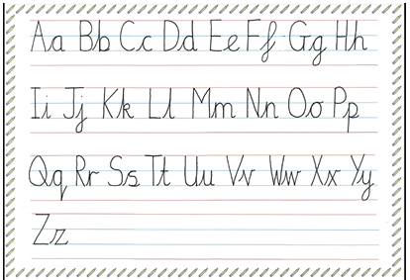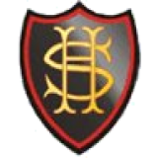

**At Sacred Heart we use a continuous cursive style of handwriting.**

**For a demonstration of how to draw each letter visit this website:**

[**https://teachhandwriting.co.uk/letter-animations-worksheets.html**](https://teachhandwriting.co.uk/letter-animations-worksheets.html)