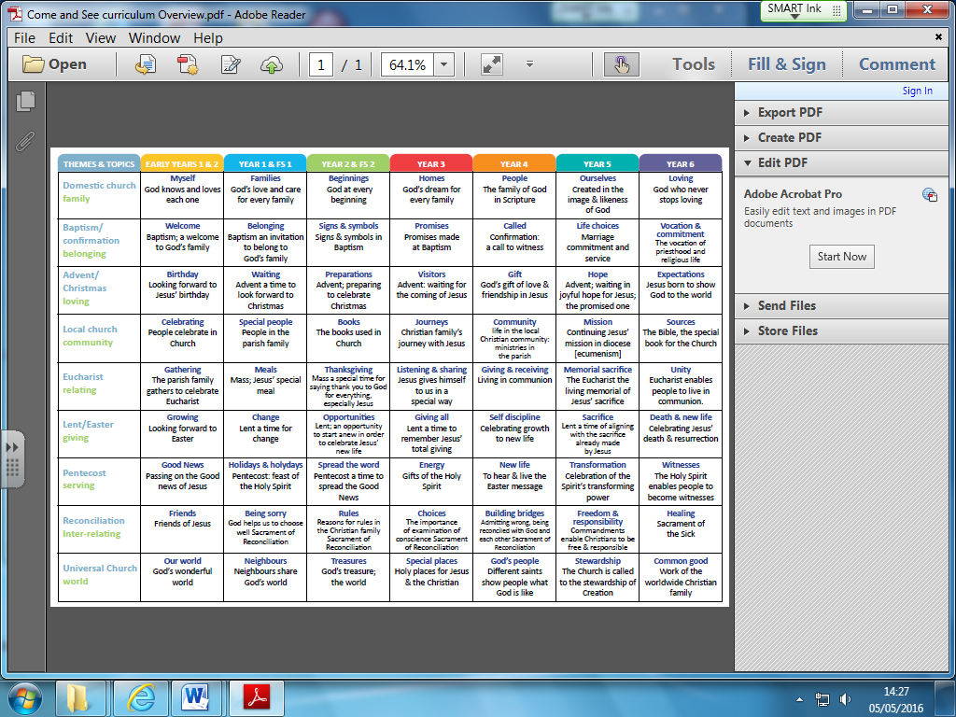

**World faiths are explicitly taught once per term**

**Autumn: Judaism**

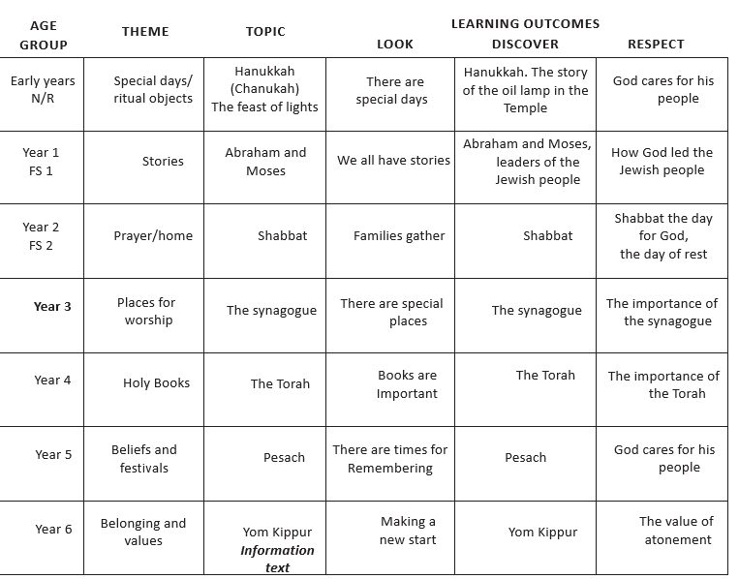

**Spring: Islam**

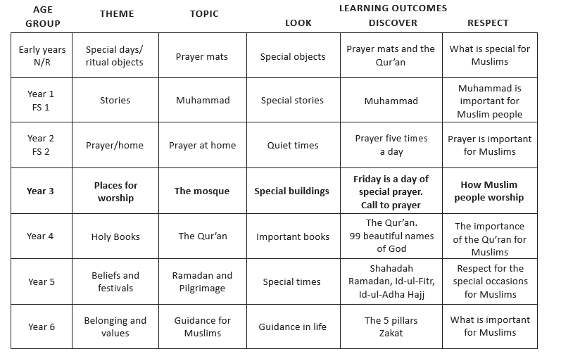

**Summer: Sikhism / Hinduism**

